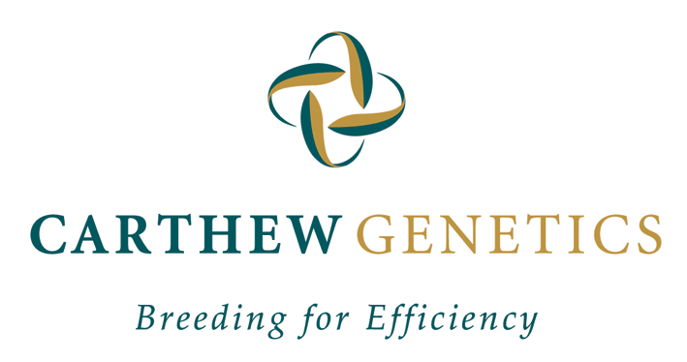

SPOT THE EWE? COOPWORTH EWE WITH TRIPLETS - DEC 2012
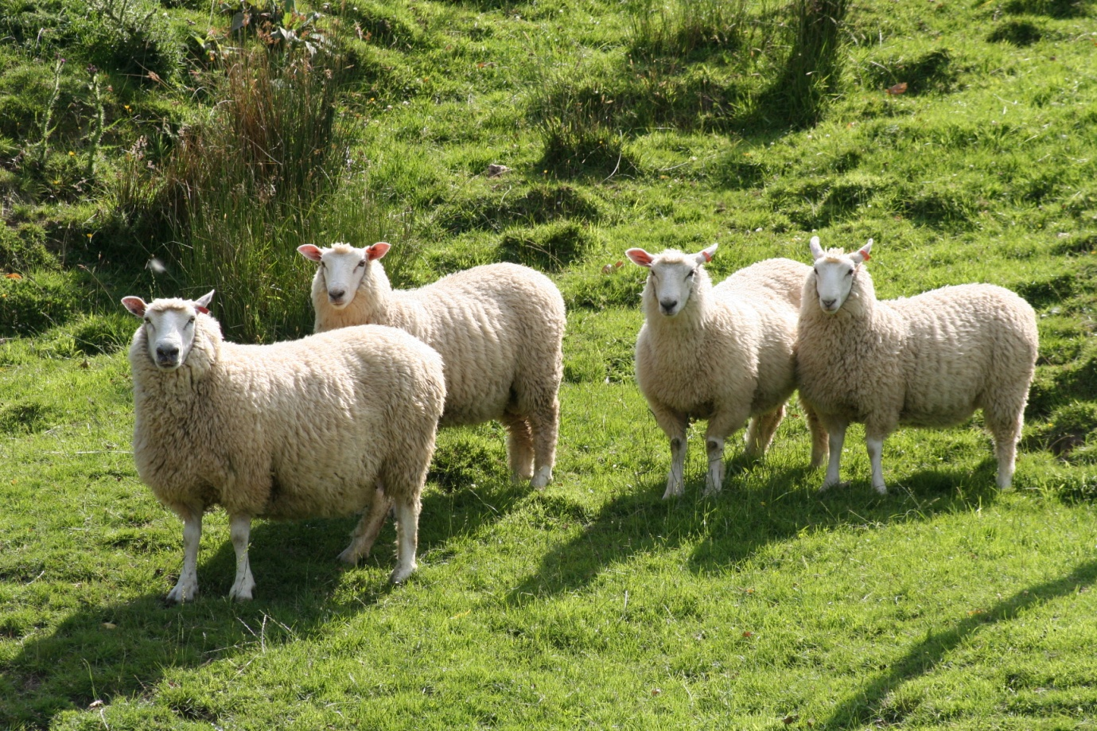
It’s been an amazing journey to date with our sheep and you, our clients, to get to where we are today and seeing everyone’s growth along the way.
In recent years, Simon and I, instead of pushing everything to the limit, have focused on embracing the “whole picture” and finding balance again.
We’ve always been looking outside the square – how to improve $ Return – Systems – Genetics – Efficiencies - we’ve pushed the boundaries at times and still are!
And this time we step back, slow down a wee bit and observe what’s going on around us...
We’ve realised that we’ve been too busy to feel and express gratitude towards our stock and land for a long time, the very things that provide a living for us. A very humbling experience ……
“Slowing down” and not “flying by the seams of your pants” constantly, has helped us to stay in touch with the animals, pastures and be more in tune with nature .
We believe, it’s our duty to care for and maintain the delicate balance of nature for the sake of the wellbeing of our children and of all future generations – we are the current caretakers.
The message is simply: for best results, we have to work together, and don’t we all perform better when appreciated?
Beauty is, that showing gratitude and appreciation doesn’t involve more labour, costs or effort – it’s simply being aware!
While on holidays overseas, wining and dining (and boy, the credit cards elaborate this….), Pascale made an interesting observation.: On nearly all restaurant menu’s it showed the origin of the meat. Even down to where & what town (or country) it came from!
Pascale thought this quite cool, consumers actually knowing what they’re eating!
But even better!
Consumers wanted to know if the meat was “happy” meat! The waiters knew about farming practices for each category and meat farmed on green pastures was definitely on top of the list for “happiness”!
After chatting with some of the customers seemed 90% out of the time they would order the “happy meat” and happily pay for it.
Pascale then found out why they’re choosing “happy” meat over other meat: “It makes us feel better to know that the meat we’re eating comes from an animal that had a happy life, more often than not, the meat tastes better and is certainly easier to digest!”
Consumers who buy our meat products are prepared to spend more on superior products that meet animal welfare and best farming practice standards.
It’s a win-win …… the animals are happy and so are we!
The sheep world has seen some fantastic gains in the last 20 years. However, with this progress, we’ve also seen a dramatic increase in structurally poor sheep. Sheep with no constitution, guts or any real core! We see a lot of sheep out there that don’t look very “happy”. You know the one’s – heads down in the yards, not standing proud - their core essence just isn’t present.
This has to change moving forward.
Optimal production not maximum production
More balance - more profit
With that in mind, we have been focusing on the basics really.
Structural soundness, performance and toughness
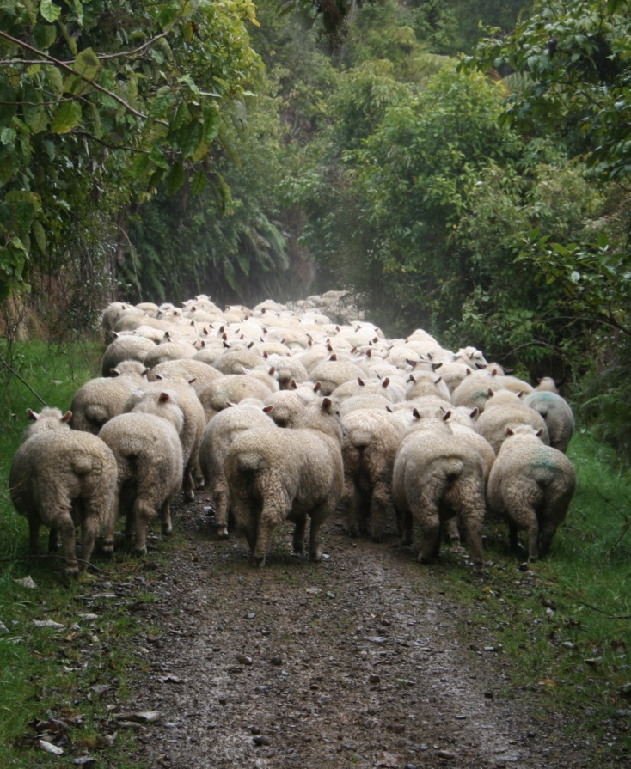
COOPWORTH EWE HOGGETS - JULY 2012

Structural soundness - Constitution
The last 5 years we’ve put a lot more selection pressure on structural soundness. We’ve been working closely together with Ian Walsh, Falkirk, who has brought another skill set into the mix. His ability to literally “undress sheep” (sorry Ian ….) and view every animal in their naked structural “being-ness”, has enabled us to dramatically improve our sheep phenotypically. We haven’t got conclusive/objective data yet to back this up but our gut feeling is, our overall gains have been huge. The sheep really do have presence!
However, it does create a challenge to again source outside sires that meet our criteria (structurally/phenotypically as well as genetically).

Performance
As you’re aware, over the last few years we’ve introduced some Romney bloodlines into our mix, resulting in a new ½ Romney ½ Coop cross. Likewise, we’ve infused a bit of Romney blood into our Coopworth flock (up to 25% is possible whilst maintaining the Coopworth classification).
It’s still early days but we’ve been rapt with both decisions to date. The Stud Romney rams we used from Richard Warren (Rawahi) have performed well on our Sire Summaries - in particular survivability, structurally correct and improved on wool type.
We’ll definitely have a better idea after lambing this year as to how they all compare.
The scanning to date has been all pretty similar to previous years.
Our early Coopworth ewes scanned 214% (3.5% scanning/kg ewe liveweight) – Coopworth and Coop/Romney X 2T ewes 202% and Coopworth and Coop/Romney X hoggets 135%
So in a drought year, very happy!
But proof of the pudding is lambs docked/weaned. Time will tell.
Growth rate and meat yield continue to be pursued vigorously. Our ram lambs are eye muscles scanned every year. This measurement is then integrated into our SIL Index. It’s highly heritable so progress can be fast (as shown on SIL Genetic Trend Graphs).

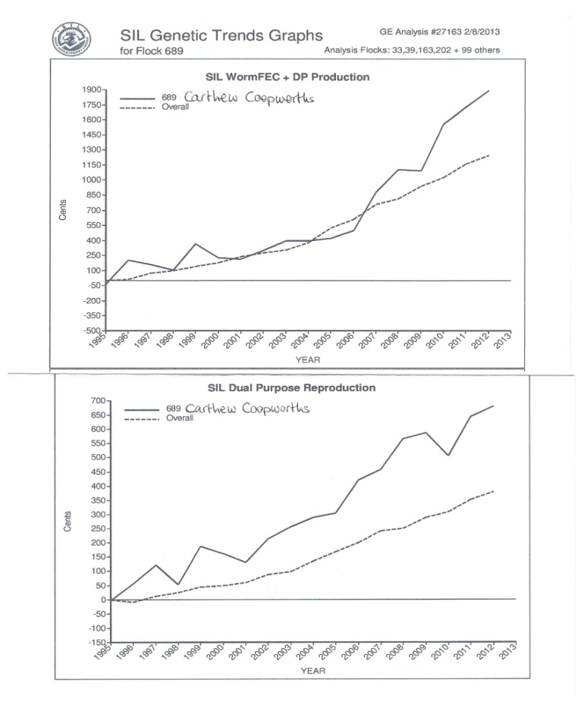
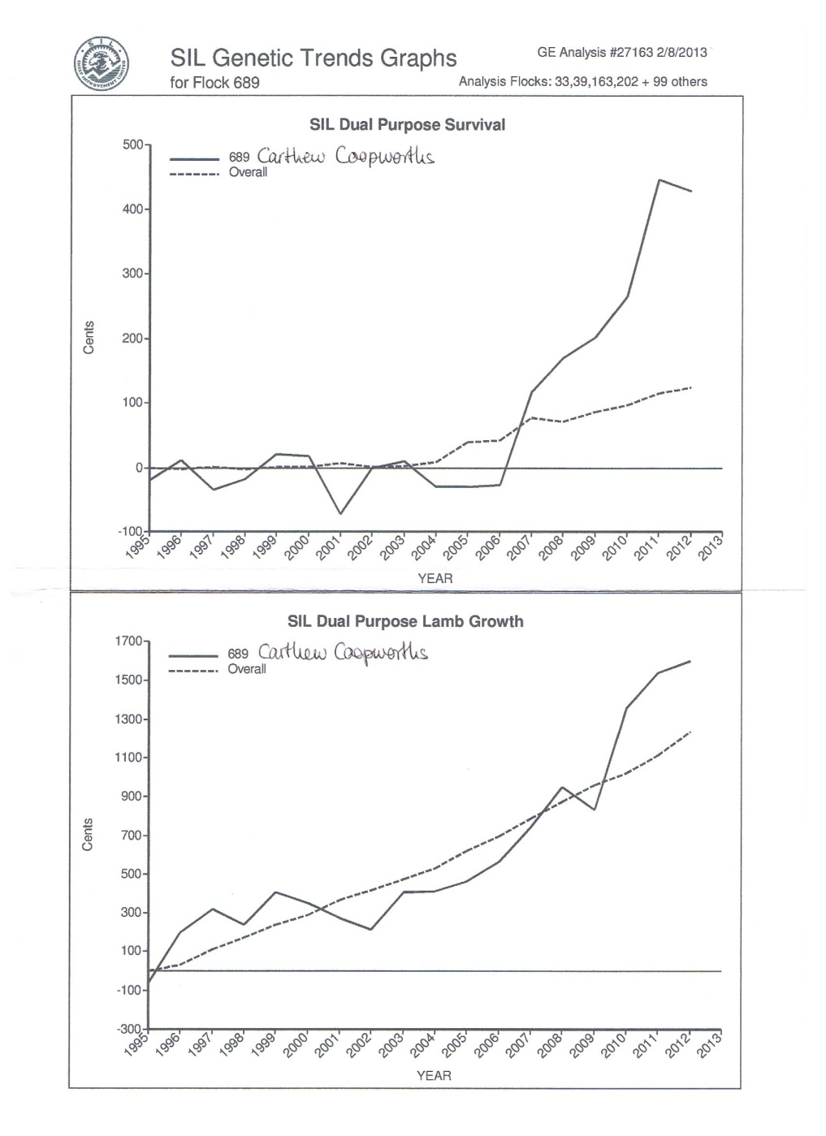

Tough
Bloody important.
Global warming, weather extremes, increase prevalence of dairy & dairy support, cropping, environmental regulations and land use restrictions, consumer driven organic & bio dynamic preferences, corporate farming & amalgamations – all mean our sheep flocks are being positioned more and more into harder hill country.
Bigger flock size means more competition, stress and potential animal health issues.
So breeding sheep that perform & shift in tough environments is paramount. We believe, only structurally sound, medium framed, “happy” sheep will survive in our sheep flocks of the future.
“Less is more”

What are we doing?
All recorded sheep are commercially driven, no preferential treatment given.
80% of the genetic progress comes from the ram, so we want to identify superior animals that excel under true commercial hill country conditions.
Ewe Hoggets – potentially 15% gain to be made here through selection (early maturity and fertility). Hogget mating is the next significant gain to be made, reducing generation interval, hence maximising genetic progress .
The ability of our sheep to perform, even in less than favourable conditions, is and always has been, what sets them apart from the rest.
Other criteria we’re working on are:
- Ewe burnout in our Coopworth flock 689 is coming through showing below average levels of burnout (following all multiply lambings)

- Parasite restistance/resilience: Over the last 20 years we have firmly been in the worm resilience camp ie not drenching our sheep and constantly making them perform in an undesirable, highly contaminated environment. A few years ago we started to use Wormfec again, believing we can now incorporate both resistance and resilience functions to breed better, tougher sheep that contaminate less in future. It’s estimated 20% of the population do 80% of the contaminating. So aiming to identify the 20% and taking them out, will reduce contamination dramatically. The spin off is less exposure to worms and more production with less chemicals.

- Facial Excema: we’re setting up a FE subgroup within our Coopworth flock. The first two years we have used top Coop FE sires, all tested as better than 0.6mg/kg liveweight, over a selection of older, high index Coop ewes. The resulting progeny are coming through the system now, so watch this space!

